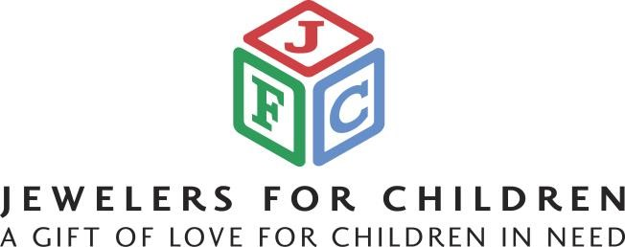

FOR IMMEDIATE RELEASE

Contact: Sara Murphy, (917)-855-8455

**Jewelers for Children Announces**

**2024 Jewelers for Children Day on September 21st**

New York, NY - Jewelers for Children (JFC), a nonprofit organization dedicated to helping children whose lives have been affected by illness, abuse, or neglect is thrilled to announce the upcoming Jewelers for Children Day on September 21st, 2024. This special day aims to unite jewelers across the country in a collective effort to make a positive impact on the lives of children facing various forms of adversity.

Since its inception, JFC has donated more than $62 million through its charity partners St. Jude Children’s Research Hospital®, Make-A-Wish® America, the Elizabeth Glaser Pediatric AIDS Foundation, and the National CASA/GAL Association. JFC also provides support to Make-A-Wish® International and the Organization for Autism Research.

Jewelers for Children Day serves as a reminder of the significant role the jewelry industry plays in supporting these charitable causes and making a difference in the lives of children.

One of the key aspects of Jewelers for Children Day is that there is no monetary contribution necessary by the retailer in order to participate. JFC believes that every retailer can contribute by raising awareness about the event and the essential work they do to support children in need. By participating, retailers have the opportunity to showcase their commitment to philanthropy and community engagement.

"We are thrilled to celebrate the potential for all children to thrive through the support of our nonprofit partners," said David Rocha, JFC Executive Director. "JFC Day gives jewelers the opportunity to work with their communities to raise awareness of JFC’s mission and the devotion of the industry to kids in need."

For more information about Jewelers for Children and Jewelers for Children Day, please visit www.jewelersforchildren.org. To request access to the personalized Video News Release, please complete the sign up process on the JFC website.

About Jewelers for Children

Jewelers for Children was founded in 1999 by the U.S. jewelry industry with the mission of helping children in need. Since its inception, JFC has donated more than $62 million to programs benefiting children whose lives have been affected by illness, abuse or neglect through our charity partners St. Jude Children’s Research Hospital®, Make-A-Wish® America, the Elizabeth Glaser Pediatric AIDS Foundation and the National CASA/GAL Association. JFC also provides support to Make-A-Wish® International and the Organization for Autism Research.

# # #